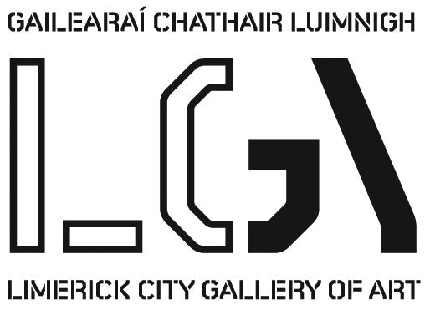
Gillian Kenny

The Family – Statement
This current series of paintings, track the most transformative period of my life the arrival of my first child My practice has often been described as Social Realism, particularly my earlier work, which mainly depicted the physical landscape of cities such as Belfast and New York. I have always been interested in the dialectics that arose between the use of photographic elements and the more physical painterly side of my practice. Travel and transitory glimpses of cities informed my work and indeed the reality of my life for many years. The large painting entitled “The Big Night.” captures that time. I depict myself getting ready for a night out, a single woman with multiple possibilities unfolding for the night ahead.
My work is generally autobiographical and recently includes the evolving themes of the domestic sphere and motherhood. My practice has evolved in tandem with my life to a concern with the body and the domestic. I found the initial demands of caring for a baby left little room for making art and I finally understood why so many female artists found it so challenging to continue their practices. A paired back approach to making art, which includes the more immediate medium of drawing, has ensured I have maintained my practice.
In the painting “Motherhood” I attempt to capture this initial feeling of a literal annihilation of personal concerns which any new mother experiences with the arrival their first baby. Your whole identity dissolves and all your concerns are focused on your offspring. I believe this is nature’s way of ensuring that you meet the demands of caring for this new life, and is transitory. The seductress aspect of the female is hinted at though the drapery referring to the bedroom. That role is subsumed at that point into that of the mother. A new identity, that of a chameleon juggling all aspects of daily life including the creative side slowly emerges and is tentatively worked out. The shoe and still life series are essentially metaphorical family portraits attempting to capture a sense of the absent wearer. My emotional attachment to each image and family member is my rationale for depicting these simple things.

Biography: Gillian Kenny was born in Limerick . She studied at the Limerick School of Art and Design and completed her MFA at the University of Ulster, Belfast in 2003. She was awarded the Countess Markievich medal for painting by the United Arts Club Dublin in 2000. She has exhibited her work regularly at venues such as EV+A, the Hunt, and Limerick Printmakers, and the Lab Foley Street Dublin. Gillian completed a large scale solo exhibition curated by Mike Fitzpatrick at Limerick City Gallery in 2008. She has also exhibited her paintings at the Spectrum Gallery London, The Phatory New York, and the Engine Gallery Toronto. She now lives in Limerick City and works from her studio at Vereker Gardens.

Selected Exhibitions: 2014 Elements - Friars’ Gate, Kilmallock; 2014 Curtor’s Choice -Hunt Museum, Limerick; 2014 Synergy -Bourne Vincent Gallery UL.; 2014 Personal Choice - Limerick School of Art and Design; 2013 Encounters OPW Collection- Touring Derry, Cork and Dublin;2012 Female Artists from the Collection- Limerick City Gallery of Art; 2012 Art and Style-Brown Thomas Dublin; 2011 Distance - Platform Arts, Belfast; 2011 Studio Artists Past and Present -Contact Studios Limerick; 2010 Gallery Artists’ Summer Show -The Molesworth Gallery Dublin; 2010 The Boyle Arts Festival -Kings House Roscommon; 2009 A Place to Stay (Solo Show)-Limerick City Gallery of Art; 2008 The Boyle Arts Festival -Kings House Roscommon; 2008 Presence- Limerick City Gallery of Art; 2007 Salon Show - The Engine Gallery Toronto; 2007 The Boyle Arts Festival - Kings House Roscommon;2007 Devotion -Glencree Visitor Centre; 2006 Devotion - The Lab Foley Street Dublin; 2006 Talking Point -Axis Arts Centre, Ballymun; 2005 Suburban Recollections (Solo Show) Droichead Arts Centre,Drogheda; 2005 Walk on By-The Limerick Printmakers;2005 Rita Duffy and Friends -The Spectrum Gallery, London; 2004 Disposed (Solo Show) The Phatory 618 E 9th Street NY, USA; 2004 Quadrant- Belltable Arts Centre, Limerick; 2003 Ochtar - Hunt Museum, Limerick; 2003 Howl - The Phatory, 618 E 9th, New York, USA; 2003 RDS - RDS Dublin; 2003 Belfast Now -Waterfront Theatre, Belfast; 2003 Slippery Slope -Catalyst Arts, Belfast; 2003 EV+A 2003 -Limerick City Gallery of Art; 2003 Art in Ulster-Lamont Cultural Institute, Ballymena; 2002 Suburbia (Solo Show) - Doswell Gallery, Limerick; 2002 See What I Mean - Queens University Gallery Belfast; 2001 From Ritual to Romance -Catalyst Arts Belfast.; 2001 EV+A 2001 Limerick City Gallery of Art ; 2001 Mechanisms -The Revenue Commissioners, Limerick

The Life Cycle Studies, 2014
Mixed media on paper
40 x 40 cm (unframed) (each)
series of 7 drawings

The Life Cycle Series, 2014
Oil on canvas
40.5 x 40.5 cm (unframed) (each)
series of 6 paintings

Motherhood, 2014
Oil on canvas
91 x 61 cm

The Big Night Out, 2009
Oil on canvas
92 x 122cm

The Life Cycle Metaphors, 2014
Oil on canvas
40 x 56 cm

Exhibition runs 28th November 2014 to 8th January 2015

For further information please contact Siobhan O’Reilly - siobhan.oreilly@limerick.ie Tel: 061 310633

Opening Hours: Monday- Friday 10-5.30, Thursday 10-8.30; Saturday 10-5pm & Sunday 12-5pm
Closed on Bank Holidays

